Project Specification – Capital Round

**Team 15:**

**Sergey Astretsov**

**Fangming Lu**

**Arpita Shrivastava**

**Siddharth Subramanian**

**Project description**

The website that the team is planning to build is called **Capital Round**. It primarily serves as a crowd-funding platform that facilitates interactions between entrepreneurs and investors. One of the primary features of the website is to provide a medium for startup companies to showcase their novel products to the investors. Consequently, it allows investors to fund startup products of their choice. Apart from incorporating social-networking features, Capital Round aims to create an ecosystem of startups and investors providing multiple functionalities such as mentoring, campaigning, monitoring etc.

We are planning to implement the website using Ruby on Rails. This is because Ruby on Rails has an in-built MVC architectural pattern.

**1. List of Actions**

|  |  |  |  |
| --- | --- | --- | --- |
| **ID** | **Name** | **Description** | **Users** |
| 000 | Register | Standard registration process for users to create an account in the web application | All Users |
| 001 | Login/Logout | Standard, session-based login and logout feature implemented in any web application. | All Users |
| 002 | Create/Update/Delete profile | Users of the web application can actively create, update, and maintain their profiles by adding relevant information that is seen in standard social-networking websites. | All Users |
| 003 | Start a company | Startup owners can actively start a company for which they seek funding. | Startup owners |
| 004 | Update and maintain a company that is started  Additional (child) actions include:  - Add/Edit team members - Upload documents related to the company - Add detailed information about the company such as products, target market, customers etc. - Add/Update company news | Startup owners can create a profile by adding relevant information about their company. This is where startup owners can showcase their companies, related products, and people involved. | Startup owners, Team members of the startup |
| 005 | Start a crowdfunding campaign | Startup owners can start a campaign for raising funds for the companies already started by them | Startup owners |
| 006 | Invest money on a company  Additional (child) actions include:  - Pick a startup to invest  - Approve legal terms  - Charge investor  - Transfer money to startup and equity to investor (additional) | After a campaign has been started, investors can invest money on a company of their choice | Investors |
| 007 | Access company profile | Startup owners and investors can view the profile page of a company | All Users |
| 008 | Access user profile | Startup owners and investors can view the profile page of another user | All Users |
| 009 | Access campaign profile | Startup owners and investors can view the campaign page of a company | All User |
| 0010 | Accept investment and transfer equity | Startup owners can accept/reject investments and based on the amount of investment made, startup owners can transfer equities of their companies to investors | Startup owners |
| 0011 | Become a mentor | Users can have an option of becoming a mentor for startup companies of their interest | Mentors |
| 0012 | Accept mentorship | Startup owners can accept/reject mentorship of mentors | Startup owners |
| 0013 | Become a follower | Users can have an option of becoming a follower for startup companies of their interest | All User |
| 0014 | Search startups | Any user should be able to search a startup based on the text entered | All Users |
| 0015 | Approval team | Approve (change status) of a campaign so it can start raising capital from the platform | All Users |

**2. List of Models, Controllers and Views**

All Models, Controllers and Views are corresponded to the actions described above. The complete list of Models (and DB), Controllers and Views are presented in the following diagrams:

***Diagram 1. Notations.***

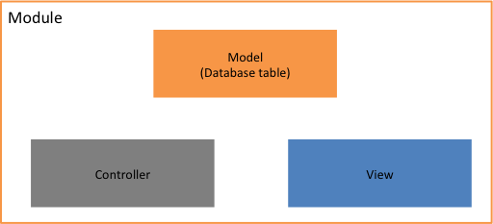

***Diagram 2. General structure.***

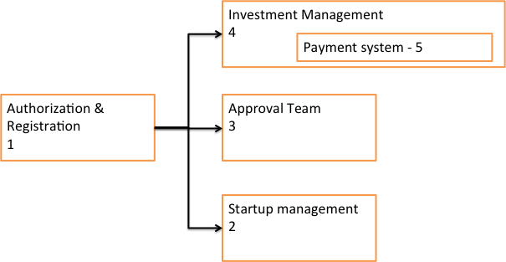

***Diagram 3. Authorization and Registration module.***

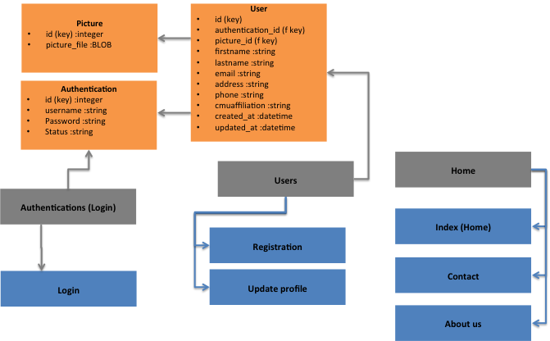

***Diagram 4. Startup module, Models and Controllers.***

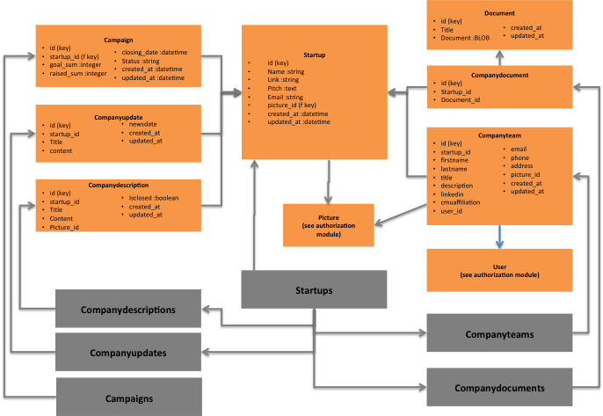

***Diagram 5. Startup module, Controllers and Views.***

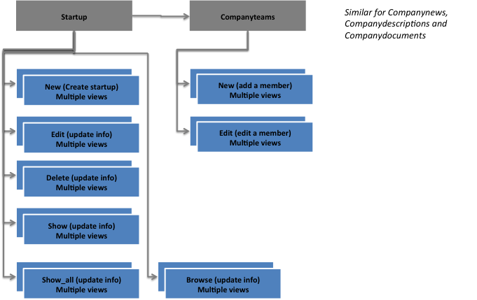

***Diagram 6. Approval Team module.***

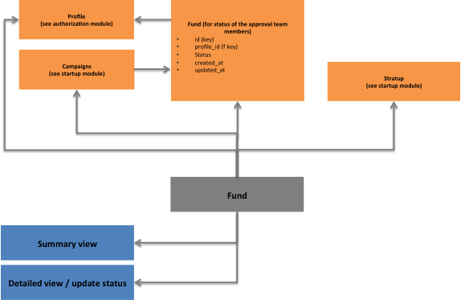

***Diagram 7. Investment management module.***

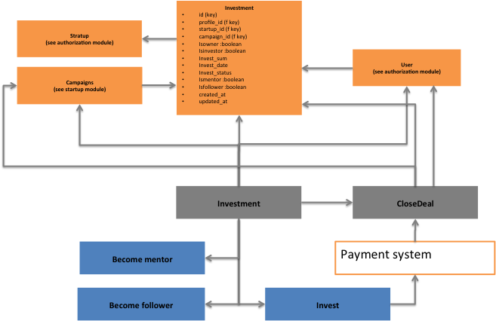

**3. Mock-up and Prototypes**

Here are mock-up of the most important views:

***Picture 1. Registration view.***

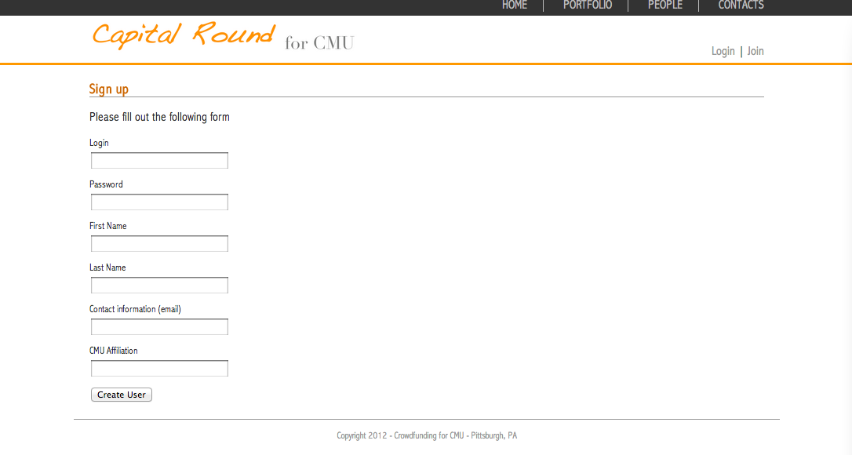

***Picture 2. Create/Update profile view.***

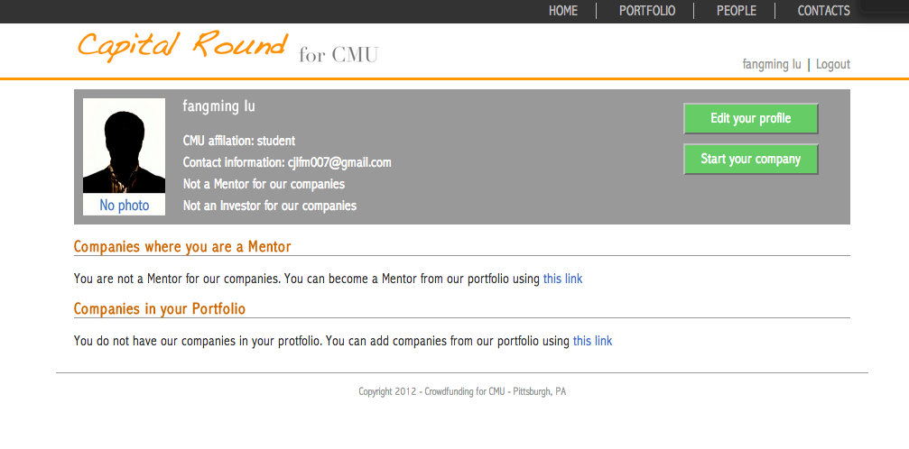

***Picture 3. Create startup view.***

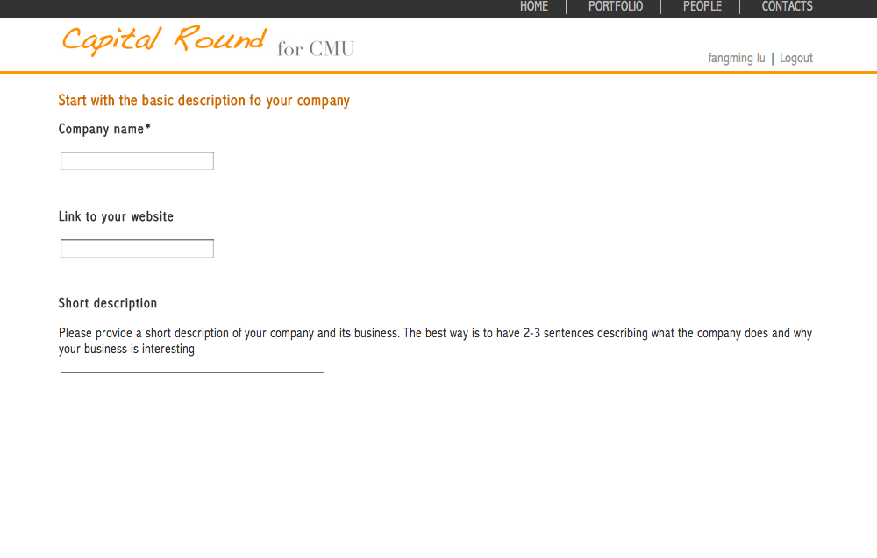

***Picture 1. Add information about startup (access to child actions of update the startup) view.***

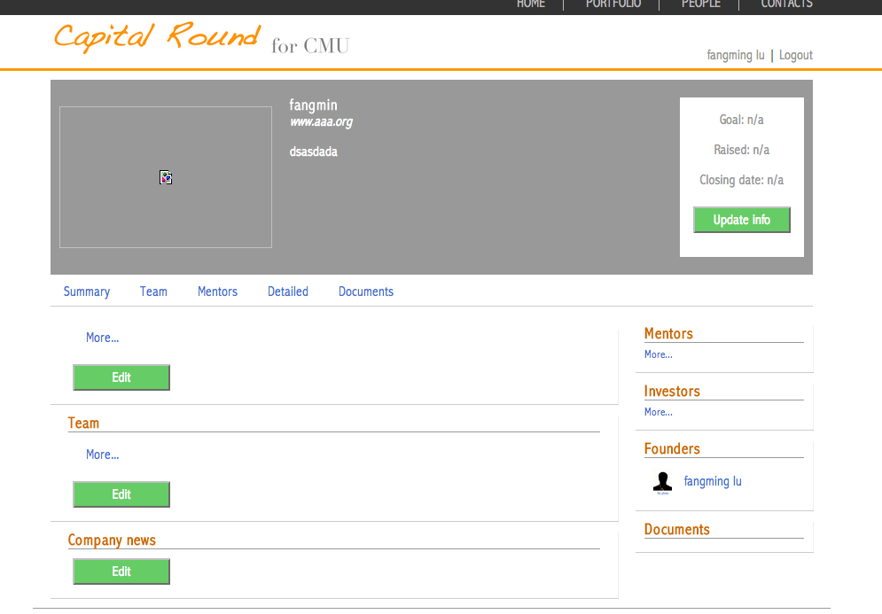

**4. Timeline**

|  |  |
| --- | --- |
| **Checkpoints** | **Actions** |
| Nov. 9   (Soft) | Register, login/ logout, Update/Delete profiles - (Startups and Investors)  000-002 |
| Nov. 11 (Hard) | Startup Management (Create startup, manage profile, start campaign) 003-005 |
| Nov. 14 (Soft) | 007-009 |
| Nov. 18 (Hard) | Investment Management 006, 010-011 |
| Nov. 21 (Soft) | Investment Management (complete) and Approval team 012-014, 015 |
| Nov. 26 (Hard) | Complete project |